RESOLUTION NO.__________

RE: CERTIFICATE OF APPROPRIATENESS UNDER THE
PROVISIONS OF THE ACT OF THE PENNSYLVANIA
LEGISLATURE 1961, JUNE 13, P.L. 282 (53
SECTION 8004) AND BETHLEHEM ORDINANCE NO.
3952 AS AMENDED.

WHEREAS, it is proposed to repaint and restore the property at
2 W. Market St.

NOW, THEREFORE, BE IT RESOLVED by the Council of the City of Bethlehem that a Certificate of Appropriateness is hereby granted for the proposal.

Sponsored by: (s)

(s)

ADOPTED BY COUNCIL THIS DAY OF

(s)
President of Council

ATTEST:

(s)
City Clerk

HISTORICAL & ARCHITECTURAL REVIEW BOARD

The applicant is proposing to repaint and restore the property at 2 W. Market St.
APPLICATION #1:

Herman & Claire Rij
2705 Bridlepath Place
Bethlehem, PA 18017

OWNER:

__________________________________________________________________________

The Board upon motion by Connie Glagola and seconded by Gen Marcon adopted the proposal that City Council issue a Certificate of Appropriateness for the following:

- Re-paint with the following color scheme:
House body – 247-CB Gateway Gray SW7644
Trim – BJM – 1575 Rainy Afternoon
Arches, Window Trim, Korbels – SW-9130 Evergreen
Front door – SW-0045 Antiquarian Brown
Porch Floors – SW-7033
Fire Escape – BJM-1494
Porch Ceilings – BJM-1494 Vale Mist
Front Steps – BJM CW

2. The motion was unanimously approved.
__________________________________________________________________________

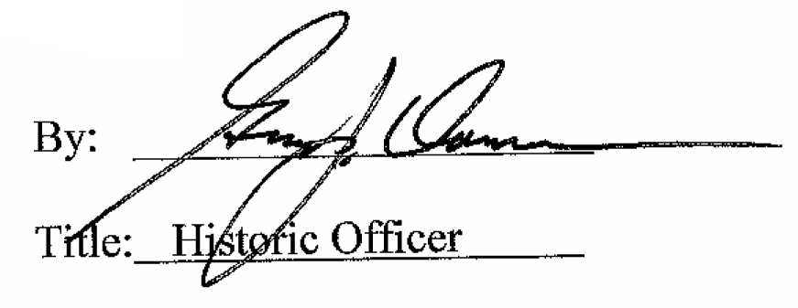

Date of Meeting: April 5, 2017

